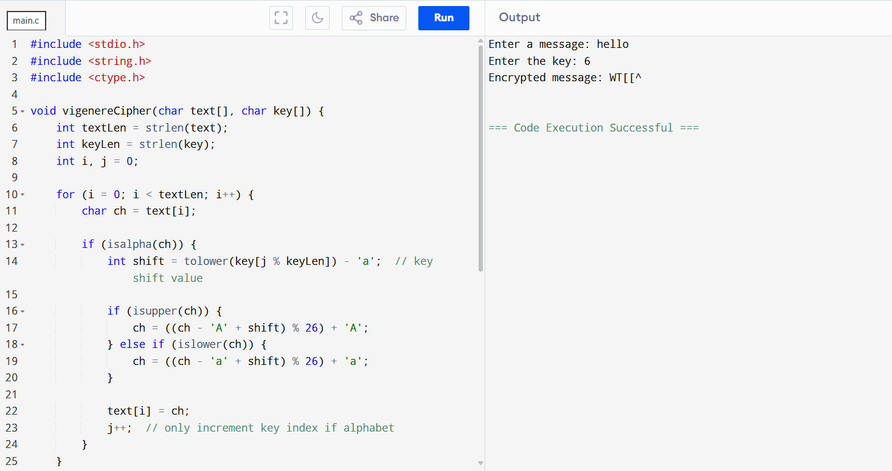4. Write a C program for polyalphabetic substitution cipher uses a separate monoalphabetic substitution cipher for each successive letter of plaintext, depending on a key.

